**Project Title: Excel Supply Chain Dashboard Project**

**Name:** Mohamad Hafizzuddin Bin Yahya

**Date:** 25/7/2024

**Contact information:**

1. **LinkedIn :** <http://www.linkedin.com/in/mohamad-hafizzuddin>
2. **GitHub :** <https://github.com/hfzzddn>

Table of content

1. Table of Contents
2. Summary
3. Introduction
4. Objectives
5. Methodology

* Data collection and preparation
* Power Query Transformations
* Creating and Configurating Pivot Table

1. Results
2. Conclusion
3. Appendices

* Appendix A: Power Query Transformations
* Appendix A: Pivot Table Configuration
* Appendix A: Charts and Graphs
* Appendix A: Dashboard Images

1. **Summary**

The Excel Supply Chain Dashboard Project aims to analyze and visualize supply chain data to support data-driven decision-making. Using Excel's Power Query and Pivot Table functions, the project focuses on monitoring sales performance, assessing delivery efficiency, identifying key customers, and analyzing sales trends. The methodology includes data collection and preparation, Power Query transformations, creating and configuring pivot tables, and visualizing data through charts and graphs.

Key insights from the dashboard include:

* Identification of best-selling products, aiding inventory and marketing optimization.
* Analysis of delivery status distribution, helping to monitor and improve delivery performance.
* Visualization of sales trends over time, enabling the identification of sales patterns and seasonal trends.
* Highlighting top customers based on sales contribution, aiding customer relationship management and marketing efforts.

The project demonstrates the effective use of Excel tools in managing and interpreting complex supply chain data, providing valuable insights for stakeholders. The interactive dashboard serves as a powerful tool for making informed business decisions, showcasing proficiency in Excel and adding significant value to any business or data analyst portfolio.

1. **Introduction**

This document provides comprehensive details about the Excel Supply Chain Dashboard project. The project aims to analyze and visualize supply chain data for a company using Excel's Power Query and Pivot Table functions. The interactive dashboard is designed to offer valuable insights into various aspects of the supply chain, thereby supporting data-driven decision-making processes. By leveraging these Excel tools, the project seeks to enhance the company's understanding of its operations, sales, and customer behaviors.

1. **Objectives**

The primary objectives of the Supply Chain Dashboard project are multifaceted, focusing on various critical aspects of the supply chain to ensure a holistic analysis:

* **Monitor Sales Performance and Identify Best-Selling Products**: The project aims to track and evaluate the sales performance across different products. By identifying the best-selling products, the company can optimize its inventory management and marketing strategies. Understanding which products drive the most sales helps in making informed decisions about stock levels, promotional activities, and resource allocation.
* **Assess Delivery Performance and Identify Areas for Improvement**: Another key objective is to assess the efficiency and effectiveness of the delivery process. The dashboard provides insights into delivery times, late deliveries, and potential risks. By analyzing this data, the company can pinpoint areas where delivery performance can be improved, such as specific regions or time periods that experience delays. This, in turn, helps in enhancing customer satisfaction and reducing operational costs.
* **Recognize Key Customers Contributing Toward Sales and Tailor Marketing Strategies**: The project seeks to identify key customers who contribute significantly to overall sales. By recognizing these important customers, the company can develop targeted marketing strategies to retain and nurture these relationships. Tailored marketing efforts can include personalized promotions, loyalty programs, and special offers, which can increase customer retention and lifetime value.
* **Analyze Sales Trends of Given Products and Enable Better Business Decisions**: Analyzing sales trends over time is crucial for understanding the market dynamics and customer preferences. The dashboard provides visual representations of sales trends, allowing the company to spot patterns, seasonal variations, and emerging market trends. This information is vital for strategic planning, forecasting future sales, and making proactive business decisions. By understanding sales trends, the company can adjust its strategies to capitalize on growth opportunities and mitigate potential risks.

Overall, the Supply Chain Dashboard project aims to leverage the power of Excel to provide a comprehensive and actionable analysis of the company's supply chain. Through detailed monitoring, assessment, and trend analysis, the project supports the company's goal of enhancing operational efficiency, improving customer satisfaction, and driving business growth.

1. **Methodology**

**Data collection and preparation.**

The original dataset includes detailed information on orders, customers, products and shipping details with the following columns:

* Type
* Days for shipping (real)
* Days for shipment (scheduled)
* Benefit per order
* Sales per customer
* Delivery Status
* Late_delivery_risk
* Category Id
* Category Name
* Customer City
* Customer Country
* Customer Email
* Customer Fname
* Customer Id
* Customer Lname
* Customer Password
* Customer Segment
* Customer State
* Customer Street
* Customer Zipcode
* Department Id
* Department Name
* Latitude
* Longitude
* Market
* Order City
* Order Country
* Order Customer Id
* order date (DateOrders)
* Order Id
* Order Item Cardprod Id
* Order Item Discount
* Order Item Discount Rate
* Order Item Id
* Order Item Product Price
* Order Item Profit Ratio
* Order Item Quantity
* Sales
* Order Item Total
* Order Profit Per Order
* Order Region
* Order State
* Order Status
* Order Zipcode
* Product Card Id
* Product Category Id
* Product Description
* Product Image
* Product Name
* Product Price
* Product Status
* shipping date (DateOrders)
* Shipping Mode

**Steps for Power Query Transformations**

The cleaned dataset after using Power Query includes the following columns:

* Order Item Id
* Customer Id
* Customer Name
* Customer Email
* Customer Password
* Customer Street
* Customer City
* Customer Zipcode
* Customer State
* Customer Country
* Customer Segment
* Product Id
* Product Name
* Category Id
* Category Name
* Product Image
* Product Status
* Product Price
* Order Item Quantity
* Order Item Discount
* Order Item Discount Rate
* Sales (with discount)
* Sales (no discount)
* Order Item Profit Ratio
* Benefit per Order
* Department Id
* Department Name
* Latitude
* Longitude
* Market
* Order Id
* Oder City
* Order State
* Order Country
* Order Region
* Order Status
* Order Date
* Days for shipment(scheduled)
* Days for shipment (Actual)
* Shipping Date
* Late delivery Risk
* Delivery Status
* Shipping Mode
* Type

**Power Query Transformations**

1. **Import Data:** Import the raw data into Power Query.
2. **Data cleaning:**

* Dropped redundant columns

1. Order Profit per Order (Same as Benefit per order)
2. Order Item Total (Same as Sales per Customer)
3. Order Customer Id (Customer Id)
4. Order Item Cardpod Id (Product Card Id)
5. Order Item Product Price

* Rename Product Card Id into Product Code.

1. **Data Transformation:**

* **Combining column.**
  + Combining Fname column with Lname column and name it as Customer Name.
* **Rearrange Column.**
* Rearrange the column to make the table much more readable.
* **Convert data types.**
* Ensured all columns have the appropriate data types for accurate analysis.

**Creating and Configurating Pivot Tables**

1. **Create Pivot Tables:**

* Sales per product.
* Percentage of delivery status per region.
* Product sales trend.
* Top 10 customer contribution to sales

1. **Configurate Pivot Tables:**

* Arrange fields in the Pivot Tables to display the desired information.
* Use filters and slicers to allow dynamic data exploration.

1. **Visualize Data:**

* Use charts and graphs to represent data visually.
* Ensure charts are clear, informative and easy to understand.
* Create a separate dashboard and put together all the charts and graph for proper representation.

1. **Results**

The Excel Supply Chain Dashboard provides the following key insights:

1. **Sales per Product:** Identifies the best-selling products allowing fir inventory and marketing optimization.
2. **Percentage of Delivery Status:** Shows the distribution of delivery status and help to monitor and improve delivery performance.
3. **Product Sales Trend:** Displays sales trends over time and enabling the identification of sales patterns and seasonal trends.
4. **Top 10 Highest Customer Contributing to Sales:** Highlights the top 10 customers based on sales contribution, aiding in customer relationship management and marketing efforts.
5. **Conclusion**

The Excel Supply Chain Dashboard project successfully demonstrates the effective application of Power Query and Pivot Tables in analyzing and visualizing complex supply chain data. The interactive dashboard offers valuable insights into various aspects of the supply chain, including sales performance, delivery efficiency, and customer contributions. These insights enable stakeholders to make well-informed business decisions based on comprehensive data analysis. This project not only highlights proficiency in Excel but also stands as a significant asset to any business analyst or data analyst portfolio, showcasing the ability to transform raw data into actionable intelligence.

1. **Appendices**

**Appendix A: Power Query Transformations.**

**Step 1: Import Data into Power Query**

1. Open Excel and navigate to the “Data” tab.
2. Select “New Query” > “From file” > “csv”
3. Choose the file name “DataCoSupplyChainDataset.csv”.
4. Click import > Transform.

**Step 2: Data cleaning**

* + 1. Remove redundant column:
* Inside power query editor, right-click the header of the desire column and choose remove.
* Refer here.

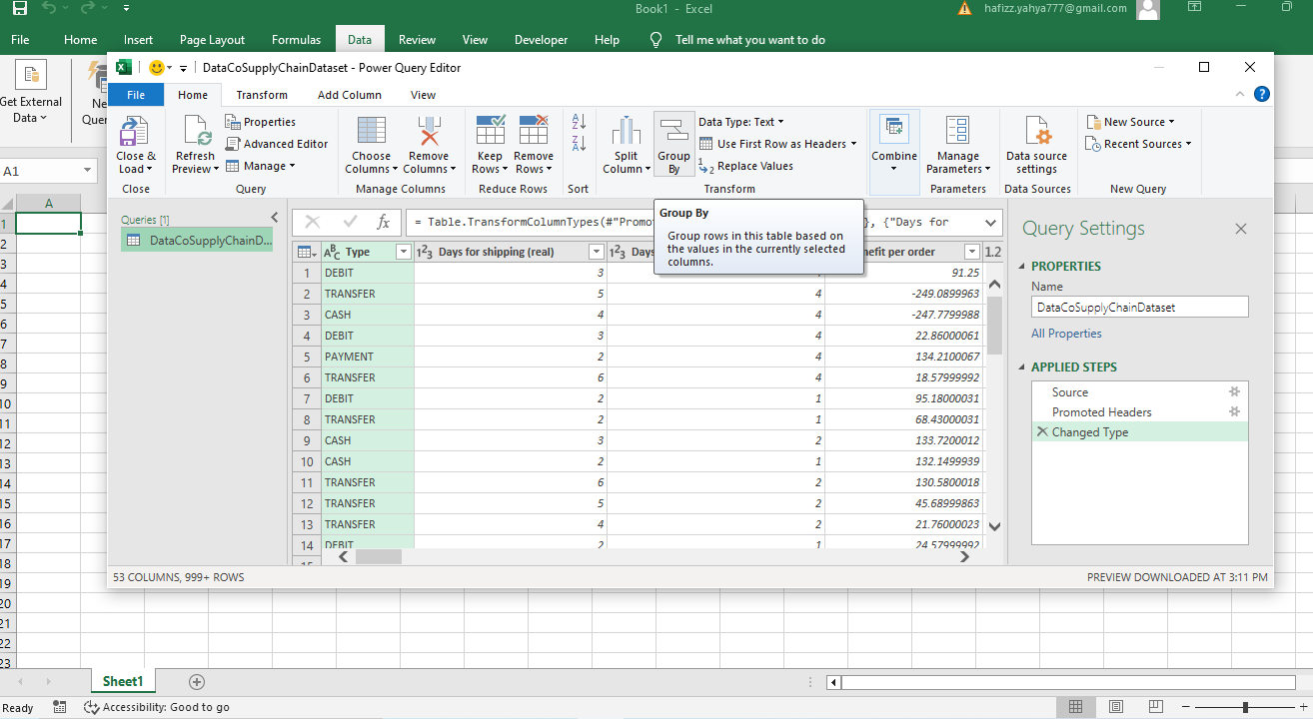

* + 1. Converting Data Types:
* Right-click the header of the desire column.
* Click change type > currency.
* Change data type for any relevant data related with currency. For example, product price.
  + 1. Data transformation
* Combine the fname and lname column.
* Click both fname and lname column.
* Go to Transform > Merge Columns > Separator > Custom > “Space Keyboard” > New Column Name > “Customer”.
* Rearrange all the column. Refer**Power Query Transformation****.**

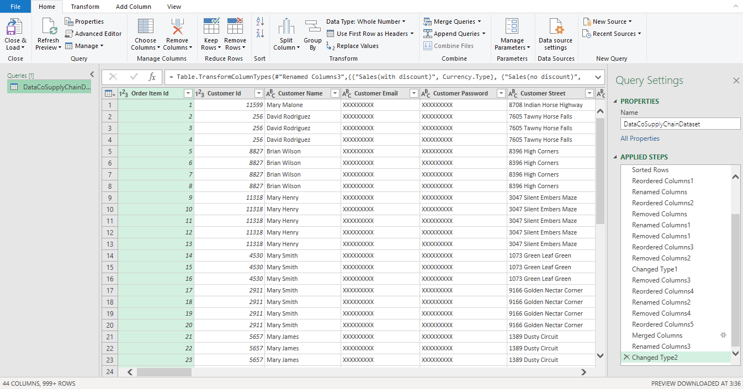

**Step 3: Import Data into Excel**

1. Go to top left of power query.
2. Click drop down button.
3. Choose close & load to.
4. Choose your desired Excel Sheet.

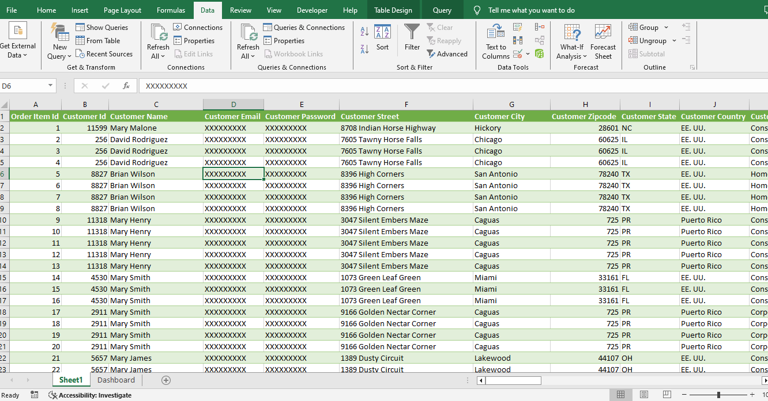

**Appendix B: Pivot Table Configuration**

1. Insert > Pivot Table > From Table/Range > New Worksheet
2. Drag Product ID and Product Name into row section.
3. Drag Sales (with discount) into Values section.
4. Click on any calculated sales.
5. Data > Sort > Largest to smallest.
6. Click on any product id.
7. Right-click > Filter > Top 10 > Click Okay.
8. Repeat the step.
9. Refer here or you can try you own analysis.

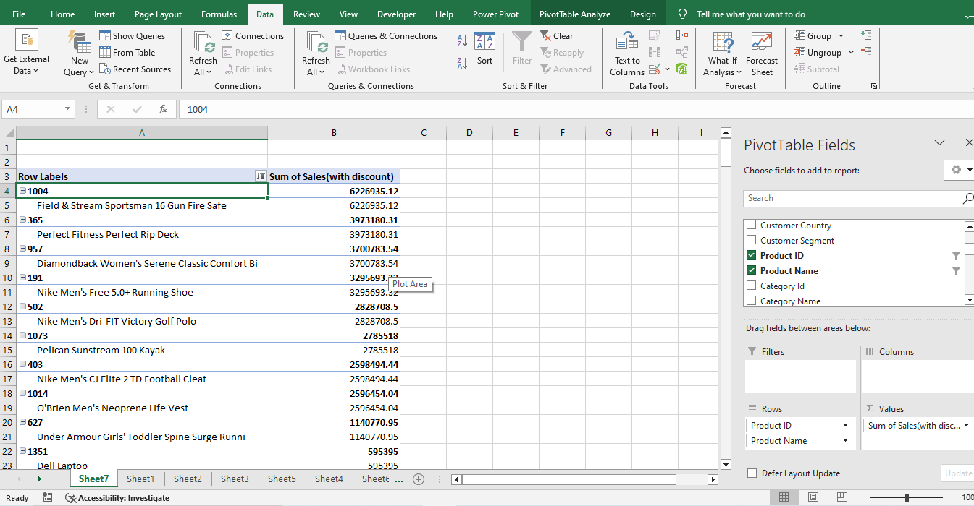

**Appendix C: Charts and Graphs**

1. Click on Pivot Table Analysis.
2. Pivot Chart > Clustered Chart.
3. Right click on chart title > Delete.
4. Right-click on the Series.
5. 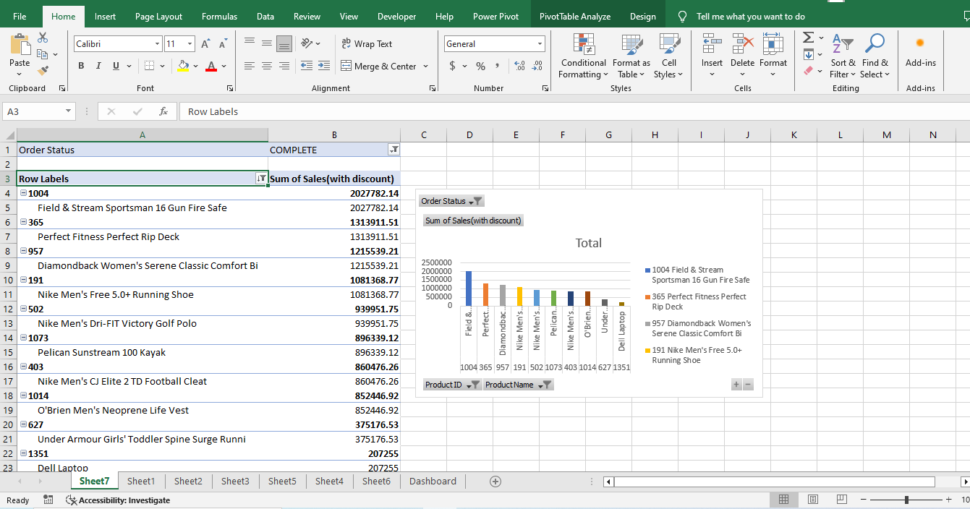Format Data Series > Fill & Line > Fill > Vary Color by Point > Close.

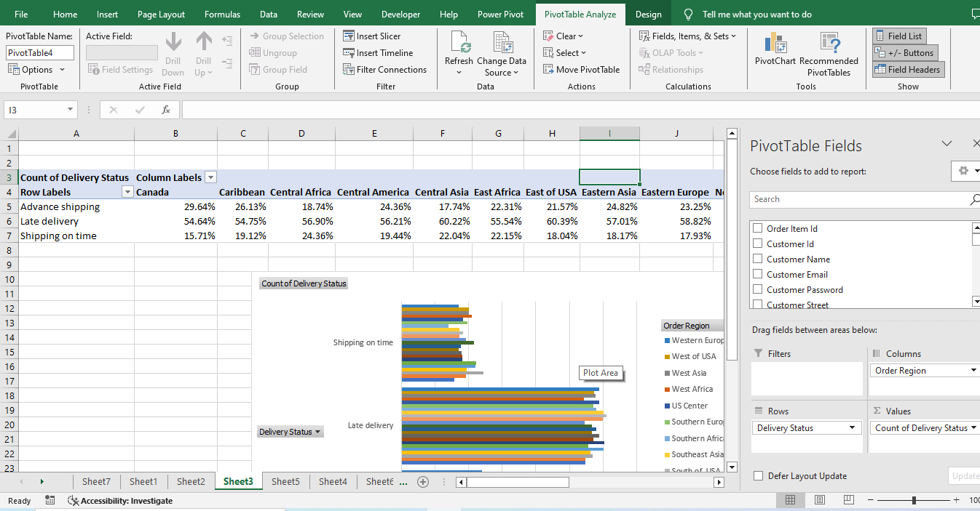

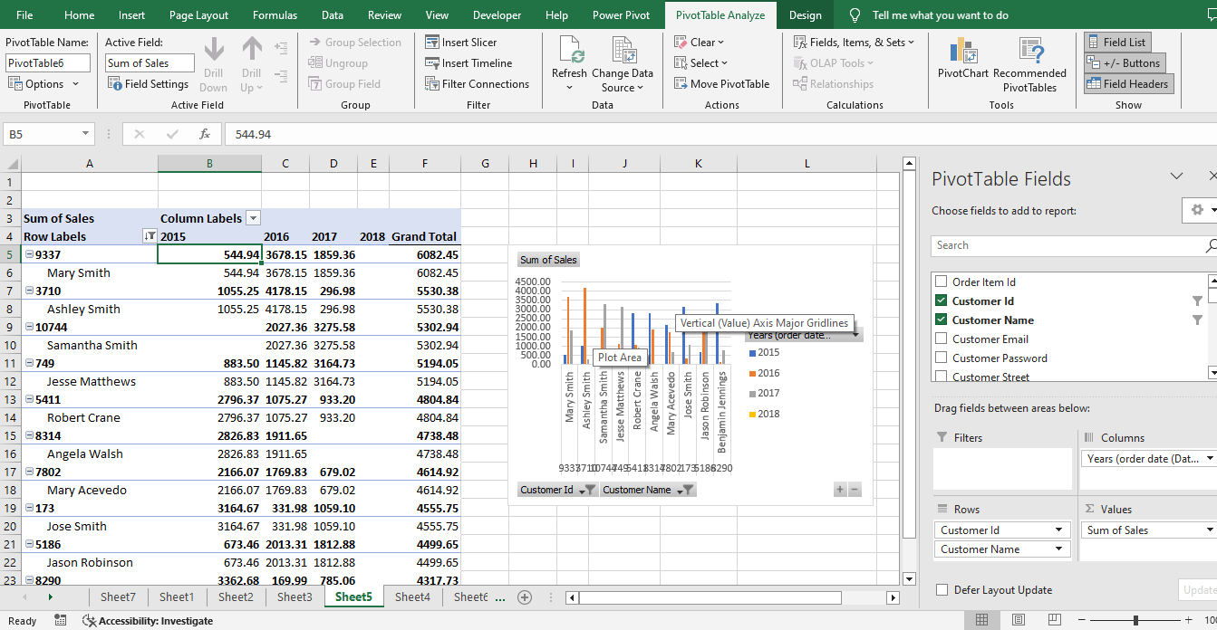

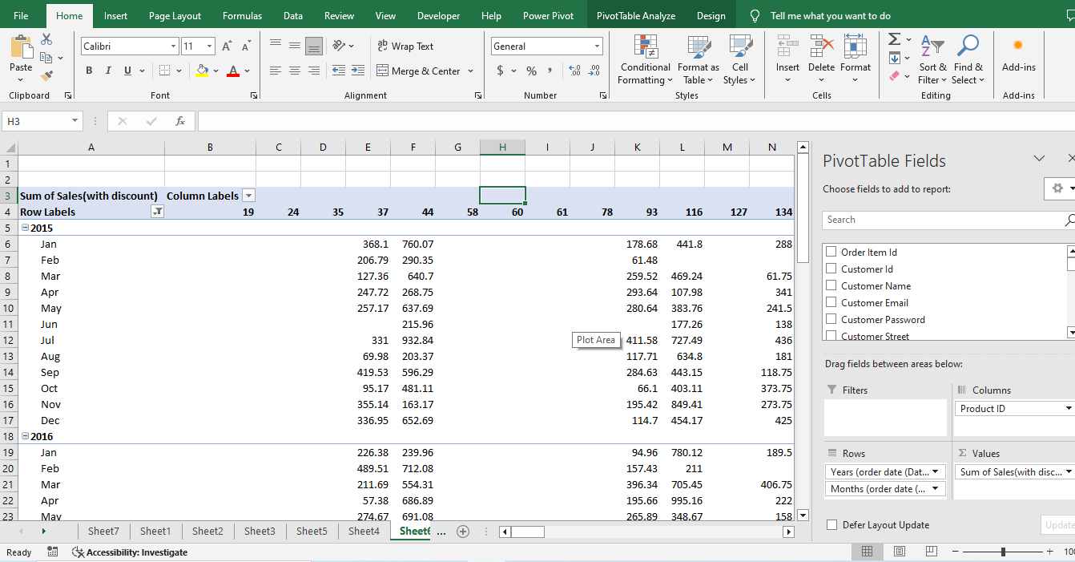

**Appendix D: Dashboard Images**

